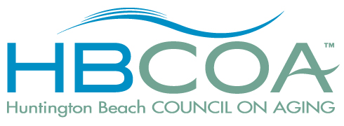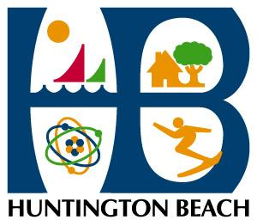
Event – Sponsorship Form
Senior Services / HBCOA Event:
Date of Event: | Time of event:
Sponsor/Company/Group name:
has agreed to Sponsorship level or Category: (choose ONE)
Non-specific sponsorship
Specific sponsorship for:
for an agreed upon donation to the HBCOA in the amount of: $

For this amount the sponsor will receive the following
List specific items, i.e, literature table, banner, announcements, etc.

Sponsor contact name and information
Name: | Email:
Address:
City, State, Zip
Phone:

HBCOA member/Staff name:
Date of agreement:

HBCOA/CFO Notes:
HBCOA Sponsorship/Invoice #:

