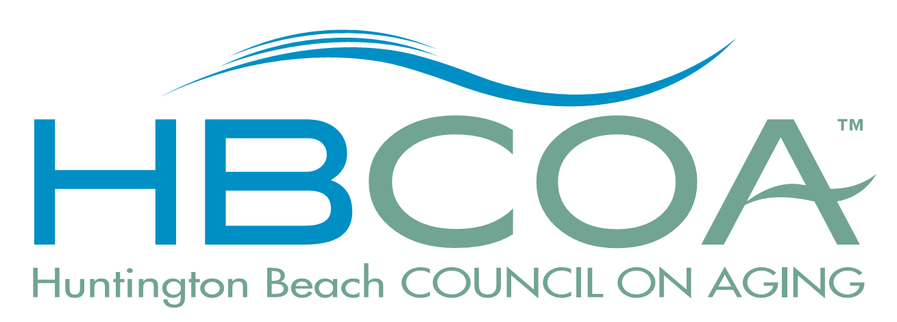
Check Request Form
MAIL CHECK DO NOT MAIL CHECK
PER MEMO INSTRUCTIONS BELOW DELIVER CHECK TO REQUESTOR

Instructions:
- Checks are ONLY processed on the 2nd and 4th Thursdays of the month.
- Please have your check requests submitted to the HBCOA by 9:00 AM on Thursdays.
- You may request one check for multiple events and account numbers.
- Expenditures must have a receipt and proper authorization, OR a Lost receipt form.

Requestor: | Date:
Payee:
Address:
City, State: | Zip Code:

Items or Services Requested (NOTE: Requests are returned/delayed if no account number!!)
Event: |  | Amount:
Event: |  | Amount:
Event: |  | Amount:
Event: |  | Amount:
Check Total: $0.00

Memo Instructions:

Supervisor/Committee Chair Approval: | Date:
PRINT NAME - Supervisor/Committee Chair Approval:

HBCOA Executive Board Approval: | Date:
PRINT NAME - HBCOA Executive Board Approval:

LOST RECEIPT

